Mrs. A’s Favorite Poems

Complied by
Gretchen Morris-Archinal
ELE 6290
October 4, 2012
Chicken Soup with Rice
Maurice Sendek

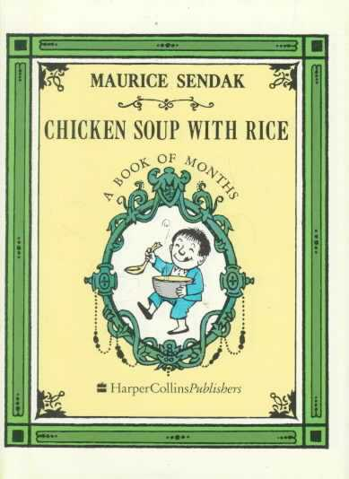
January
In January it's so nice
While slipping on the sliding ice
To sip hot chicken soup with rice
Sipping once, sipping twice
Sipping chicken soup with rice
February
In February it will be
My snowman's anniversary
With cake for him and soup for me!
Happy once, happy twice
Happy chicken soup with rice
March
In March the wind blows down the door
And spills my soup upon the floor
It laps it up and roars for more
Blowing once, blowing twice
Blowing chicken soup with rice
April
In April I will go away
To far off Spain or old Bombay
And dream about hot soup all day
Oh, my, oh, once, oh, my, oh, twice
Oh, my, oh, chicken soup with rice
May
In May I truly think it best
To be a robin lightly dressed
Concocting soup inside my nest
Mix it once, mix it twice
Mix that chicken soup with rice
June
In June I saw a charming group
Of roses all begin to droop
I pepped them up with chicken soup!
Sprinkle once, sprinkle twice
Sprinkle chicken soup with rice
July
In July I'll take a peep
Into the cool and fishy deep
Where chicken soup is selling cheap
Selling once, selling twice
Selling chicken soup with rice
August
In August it will be so hot
I will become a cooking pot
Cooking soup of course-why not?
Cooking once, cooking twice
Cooking chicken soup with rice
September
In September, for a while
I will ride a crocodile
Down the chicken soup-y Nile
Paddle once, paddle twice
Paddle chicken soup with rice
October
In October I'll be host
To witches, goblins and a ghost
I'll serve them chicken soup on toast
Whoopy once, whoopy twice
Whoopy chicken soup with rice
November
In November's gusty gale
I will flop my flippy tail
And spout hot soup-I'll be a whale!
Spouting once, spouting twice
Spouting chicken soup with rice
December
In December I will be
A baubled, bangled Christmas tree
With soup bowls draped all over me
Merry once, merry twice
Merry chicken soup with rice
I told you once, I told you twice
All seasons of the year are nice
For eating chicken soup with rice!

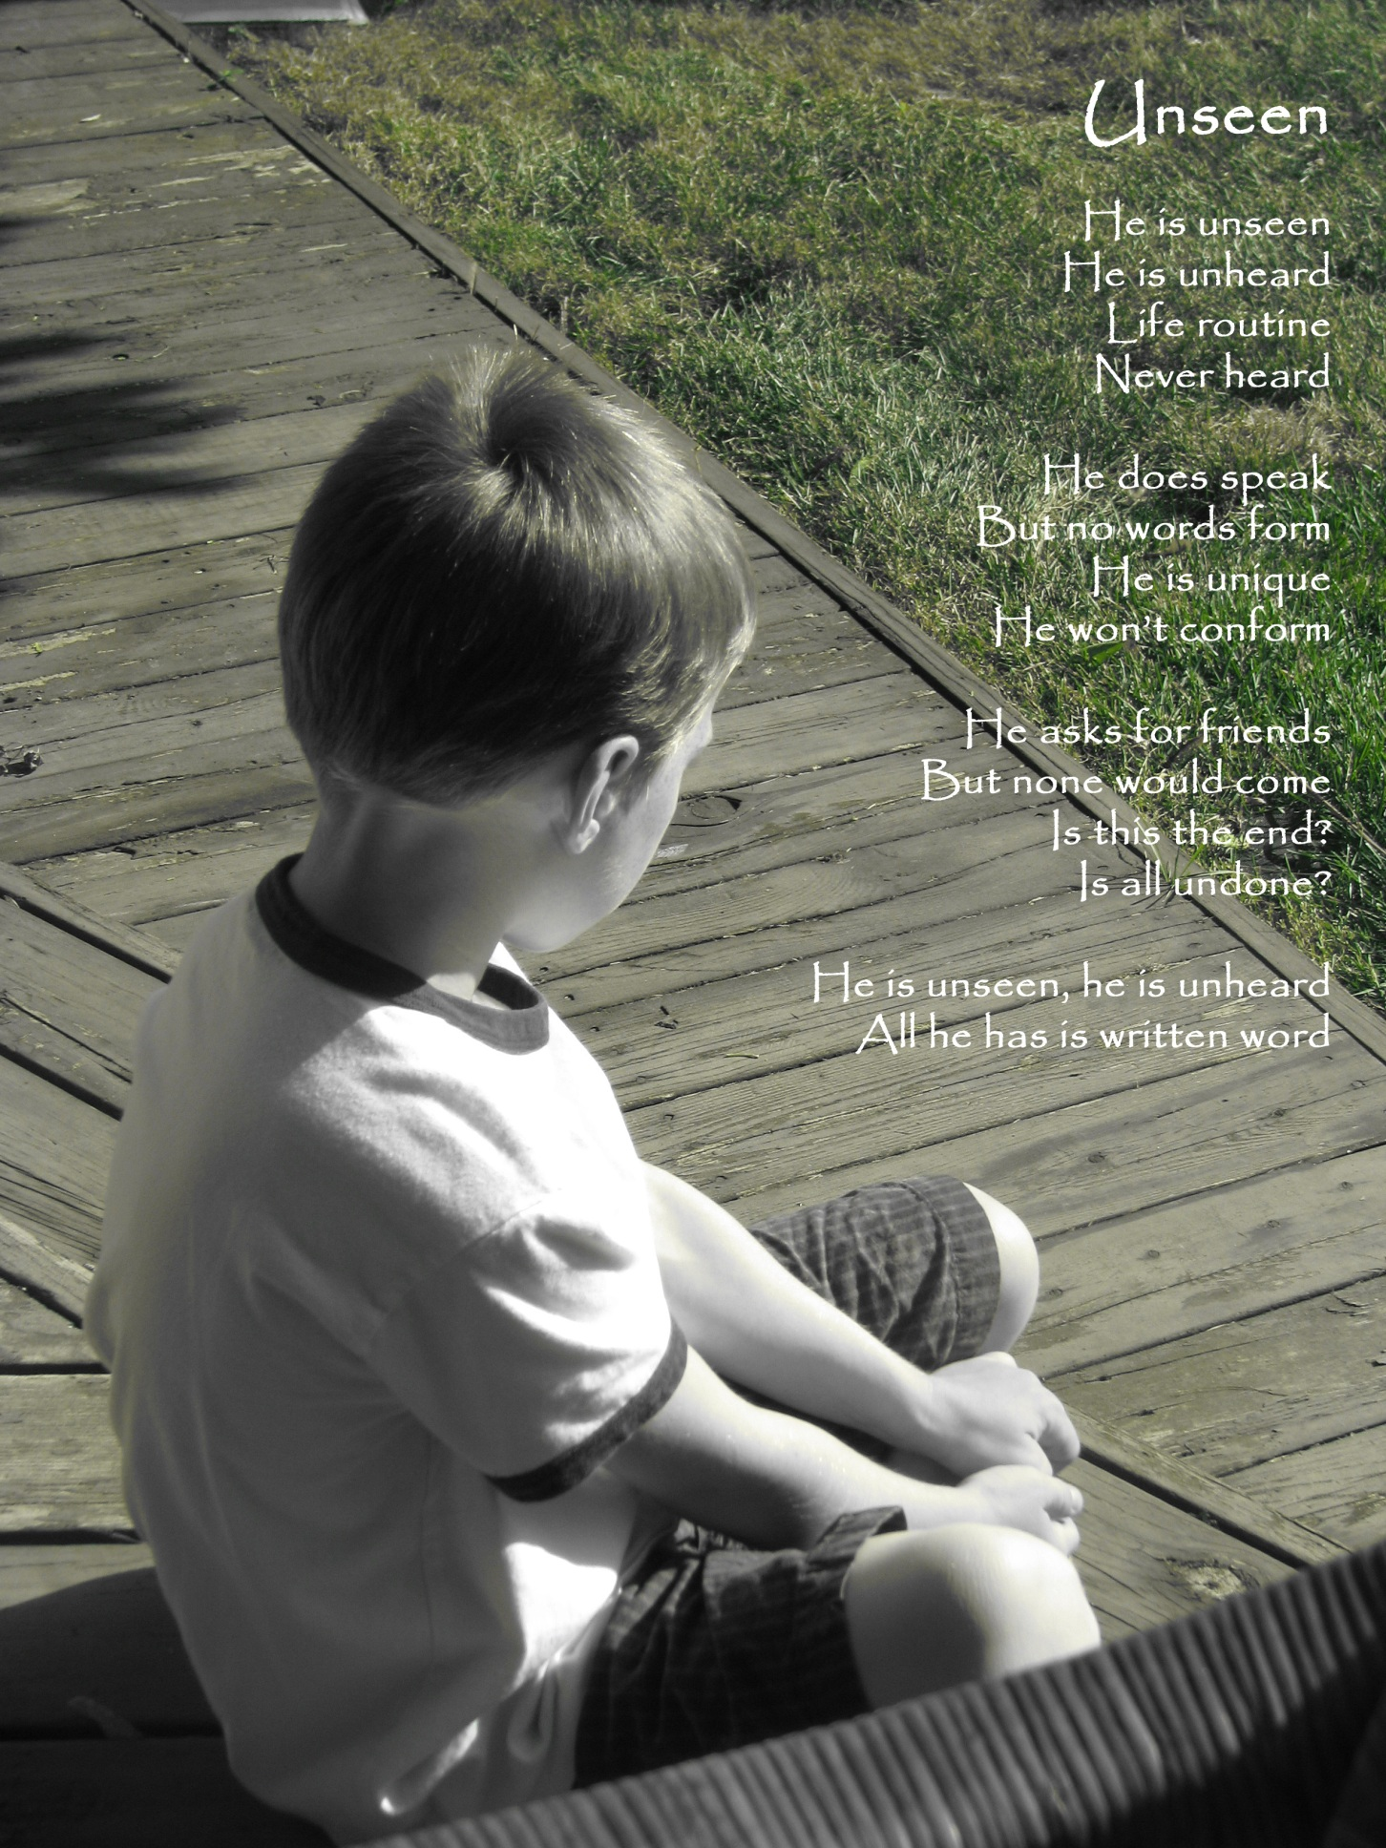
Margaret Archinal
Pierre – Maurice Sendek

Prologue:
There was once a boy named Pierre
Who only would say, I don't care!
Read his story, my friend, for you'll find
At the end that a suitable
Moral lies there
(Chapter I)
One day his mother said
When Pierre climbed out of bed
-Good morning, darling boy, you are my only joy
Pierre said-I don't care!
-What would you like to eat?
-I don't care!
-Some lovely cream of wheat?
-I don't care!
-Don't sit backwards in your chair
-I don't care!
-Or pour syrup on your hair
-I don't care!
-You are acting like a clown
-I don't care!
-And we have to go to town
-I don't care!
-Don't you want to come, my dear?
-I don't care!
-Would you rather stay right here?
-I don't care!
So his mother left him there

(Chapter II)
His father said-Get off your head
Or I will march you up to bed!
Pierre said-I don't care!
-I would think that you could see--
-I don't care!
-Your head is where your feet should be!
-I don't care!
-If you keep standing upside down--
-I don't care!
-We'll never get to town
-I don't care!
-If only you would say, I care
-I don't care!
-I'd let you fold the folding chair
-I don't care!
So his parents left him there
They didn't take him anywhere
(Chapter III)
[ Lyrics from: http://www.lyricsty.com/carole-king-pierre-lyrics.html ]
Now as the night began to fall
A hungry lion paid a call
He looked Pierre right in the eye
And asked him if he'd like to die
Pierre said-I don't care!
-I can eat you, don't you see?
-I don't care!
-And you will be inside of me
-I don't care!
-Then you will never have to bother--
-I don't care!
-With a mother and a father
-I don't care!
-Is that all you have to say?
-I don't care!
-Then I'll eat you, if I may
-I don't care!
So the lion ate Pierre
(Chapter IV)
Arriving home at six o'clock
His parents had a dreadful shock!
They found the lion sick in bed and cried
-Pierre is surely dead!
They pulled the lion by the hair
They hit him with the folding chair
His mother asked-Where is Pierre?
The lion answered-I don't care!
His father said-Pierre's in there!
(Chapter V)
They rushed the lion into town
The doctor shook him up and down
And when the lion gave a roar
Pierre fell out upon the floor
He rubbed his eyes and scratched his head
And laughed because he wasn't dead
His mother cried and held him tight
His father asked-Are you allright?
Pierre said-I am feeling fine
Please take me home, it's half past nine
The lion said-If you would care
To climb on me, I'll take you there
Then everyone looked at Pierre
Who shouted-Yes, indeed, I care!
The lion took them home to rest
And stayed on as a weekend guest
The moral of Pierre is: CARE!

Mashed Potatoes on the Ceiling

A Funny Food Poem for Kids

Kenn Nesbitt

Mashed potatoes on the ceiling.

Green beans on the floor.

Stewed tomatoes in the corner.

Squash upon the door.

Pickled peppers in my pocket.

Spinach up my sleeves.

Mushrooms in my underpants with

leeks and lettuce leaves.

Okra, onions, artichokes,

asparagus and beets;

buried neatly underneath the

cushions of our seats.

All the rest I've hidden in my socks

and down my shirt.

I'm done with all my vegetables.

I'm ready for dessert!

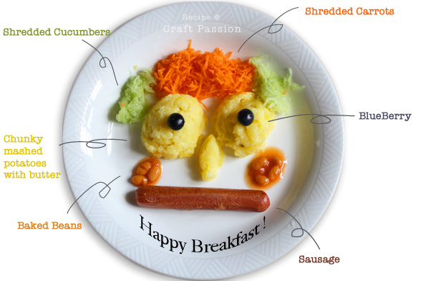

Lock and Key

"I am a gold lock."
"I am a gold key."
"I am a silver lock."
"I am a silver key."
"I am a brass lock."
"I am a brass key."
"I am a lead lock."
"I am a lead key."
"I am a don lock."
"I am a don key!"

Mother Goose Nursery Rhyme

SMELLS
Christopher Morley
Why is it that the poets tell
So little of the sense of smell?
These are the odors I love well:

The smell of coffee freshly ground;
Or rich plum pudding, holly crowned;
Or onions fried and deeply browned.

The fragrance of a fumy pipe;
The smell of apples, newly ripe;
And printers’ ink on leaden type.

Woods by moonlight in September
Breathe most sweet; and I remember
Many a smoky camp-fire ember.

Camphor, turpentine, and tea,
The balsam of a Christmas tree,
These are whiffs of gramarye …
A ship smells best of all to me!

Nursery Rhyme: A Rainbow Riddle

Answer: A rainbow

Flower Power – Mrs. Archinal
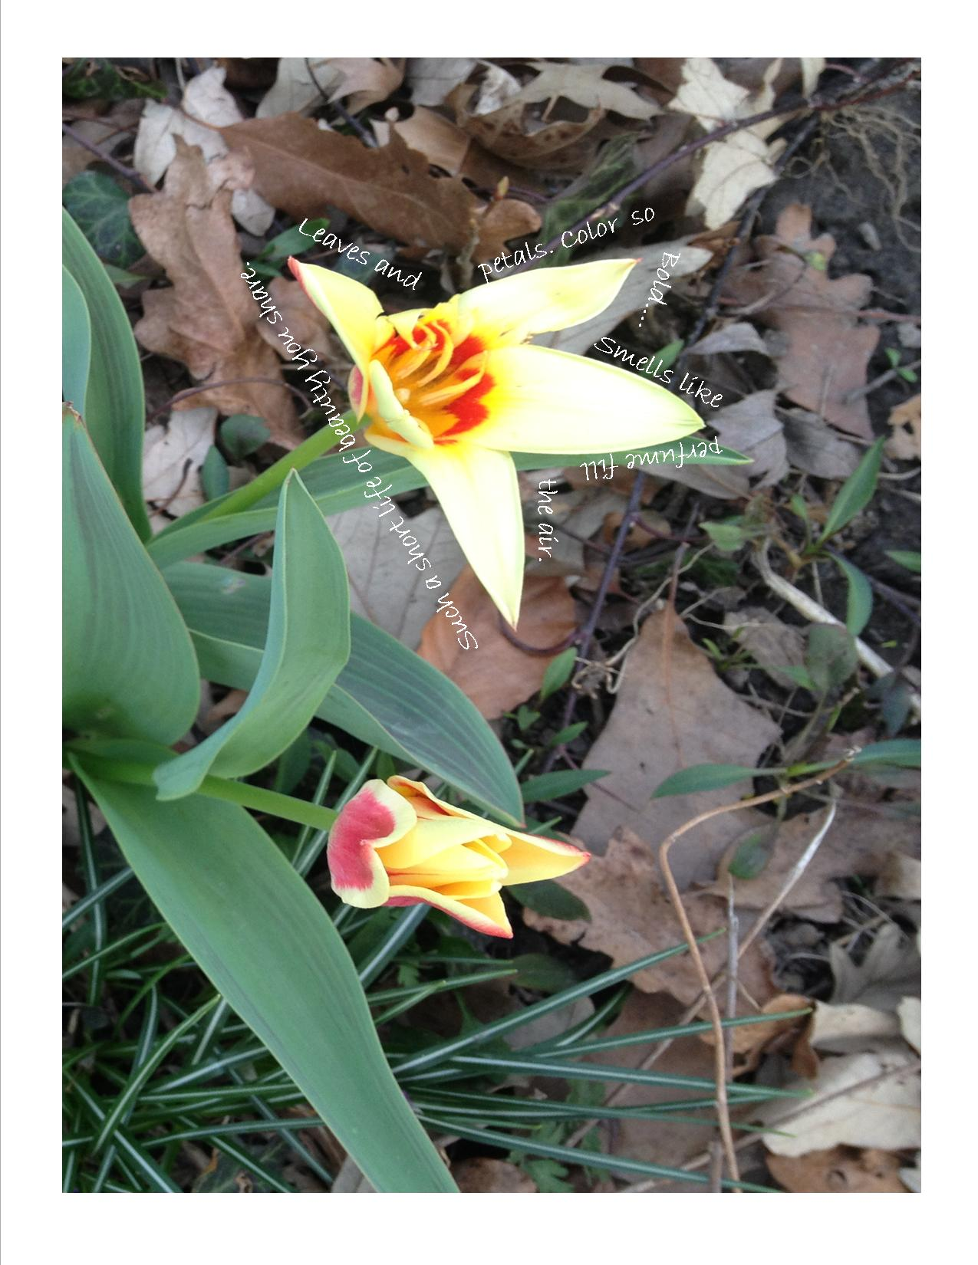

Animal Acrostic Poem
David Hammon
Illustrated by Michael S. Maydak

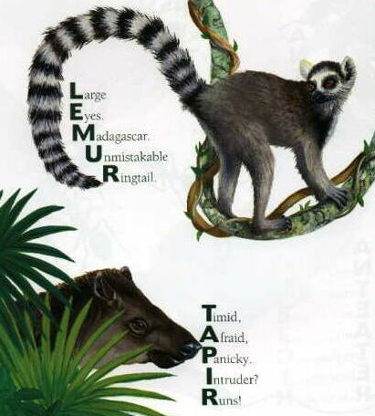

All My Great Excuses
A Funny School Poem for Kids
Kenn Nesbitt

I started on my homework
but my pen ran out of ink.
My hamster ate my homework.
My computer's on the blink.

I accidentally dropped it
in the soup my mom was cooking.
My brother flushed it down the toilet
when I wasn't looking.

My mother ran my homework
through the washer and the dryer.
An airplane crashed into our house.
My homework caught on fire.

Tornadoes blew my notes away.
Volcanoes struck our town.
My notes were taken hostage
by an evil killer clown.

Some aliens abducted me.
I had a shark attack.
A pirate swiped my homework
and refused to give it back.

I worked on these excuses
so darned long my teacher said,
"I think you'll find it's easier
to do the work instead."
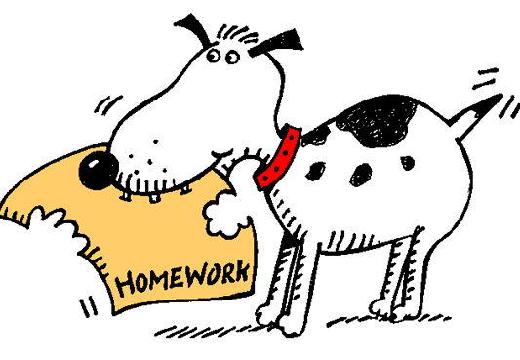

"Ode to Spot" by Data

Felis catus is your taxonomic nomenclature,
An endothermic quadruped, carnivorous by nature;
Your visual, olfactory, and auditory senses
Contribute to your hunting skills and natural defenses.
I find myself intrigued by your sub vocal oscillations,
A singular development of cat communications
That obviates your basic hedonistic predilection
For a rhythmic stroking of your fur to demonstrate affection.
A tail is quite essential for your acrobatic talents;
You would not be so agile if you lacked its counterbalance.
And when not being utilized to aid in locomotion,
It often serves to illustrate the state of your emotion.
O Spot, the complex levels of behavior you display
Connote a fairly well-developed cognitive array.
And though you are not sentient, Spot, and do not comprehend,
I nonetheless consider you a true and valued friend.

