Demographics:
Name: Gretchen Morris-Archinal Date: February 7, 2015 Subject: 8th Grade Math School: Pierce Middle School Setting: Secondary Resource Room (SRC) School District: Grosse Pointe Public Schools Lesson Plan Title: Walk the Line - Slope Review

Rationale:
Functions:
CCSS.MATH.CONTENT.8.F.A.3
Interpret the equation y = mx + b as defining a linear function, whose graph is a straight line; give examples of functions that are not linear. For example, the function A = s2 giving the area of a square as a function of its side length is not linear because its graph contains the points (1,1), (2,4) and (3,9), which are not on a straight line.
CCSS.MATH.CONTENT.8.F.B.4
Construct a function to model a linear relationship between two quantities. Determine the rate of change and initial value of the function from a description of a relationship or from two (x, y) values, including reading these from a table or from a graph. Interpret the rate of change and initial value of a linear function in terms of the situation it models, and in terms of its graph or a table of values.

Range of Writing:
CCSS.ELA-LITERACY.W.8.10
Write routinely over extended time frames (time for research, reflection, and revision) and shorter time frames (a single sitting or a day or two) for a range of discipline-specific tasks, purposes, and audiences.

The general education 8th grade math class is currently studying functions; linear equations; and slope intercept form and will have a written assessment at end of the section. This lesson is a mechanism that allows special education students an opportunity to review and write about their study of functions. It incorporates kinetic, oral and visual learning opportunities to reach a range of learning styles.

Outcomes (objectives/performance indicators):
80% of the students will correctly write the equation of a line given its graph or its slope and y-intercept. The students will also learn the effects of changing the slope and y—intercept on the graph and the equation of the line as measured by a worksheet assessment (summative assessment in part 7) and by the written Tweet It Back response cards.

Materials needed:
- Large floor space – optimal 20’X20’
- Wide masking tape – different colors – for axis’ as well as lines
- Sharpie or magic marker
- Graphing calculator or iPad app attached to smart board Desmos app on iPad or iPhone - students may utilize their personal equipment
- Handout with activity directions and equations
- Handout with writing prompt Pencils for students

Teacher Procedure/Development:
Introduction: After students are seated ask them what they know about slopes, linear functions and the slope intercept form. Discuss and record what they know on the smart board. Explain that they will be a human graphing calculator and drawing lines on the floor. Have them help push back the furniture so that there is a large open space in the room.

Methods/Procedures:
- The teacher will select 2 students to place a 15-20 ft strip of masking tape (or laminated adding machine tape) on the floor. Then the teacher will select 2 students to place another 15-20 ft strip of tape on the floor perpendicular to the first strip. Use the tiles on the floor as graph paper. - Cooperative groups Next the teacher will ask students, one at a time, to take the magic marker and write on the tape the following: - direct instruction if necessary
  - x-axis
  - y-axis
  - 0 at the origin
  - scale the positive x-axis
  - scale the negative x-axis
  - scale the positive y-axis
  - scale the negative y-axis
- The teacher will divide the class into 2 groups of 2 or 3. (Group sizes and number of groups can be modified based on size of class) While one group is on the graph, the other group will be figuring out the function on the smart board. Calculators may be used to solve the equations - cooperative groups
- Group A will solve for x and y using x values of 2, 0 and -2 for equation y=x+3. Once the table is solved, Group B will illustrate by standing on the coordinates and laying a piece of tape on the ground through the coordinates. Group A will then solve y=x-3 and Group B will plot the different points and tape the ground. Teacher will ask what differences and similarities the groups see in the lines as well as the slope and the y-intercept.
- Next the groups will switch places and Group B will solve the problems while Group A will plot the graph. The following equations will be solved: y = 2x and y=-2x. Again the teacher will follow up with similarities and differences as well as the slope and the y-intercept.

- Formative Assessment - monitor for progress.
  - Reteach and continue practicing as necessary using additional equations and continue to alternate groups. Equations will include: y=3x+5, y=3x-5,y=-3x-5, y=-3x+5 y=2x+3, y=-2x+3, y=2x-3, y=-2x-3
  - If time allows continue with steps 6-7 and the closure.
  - If there is not enough time go to the closure and do steps 6-7 the next day.
- The teacher will demonstrate using the Desmos app on the iPad and projected on the smart board. Students will input on their devices along with the teacher - Direct instruction. Write the equations of the lines in slope-intercept form. Then draw the graph of the lines, labeling each line with its equation. Answer the questions that follow:
- slope = 1, y-intercept = 3
- slope = 1, y-intercept = -3
- slope = 1, y-intercept = 0
- slope = 1, y-intercept = -1
    - How are these lines alike?
    - How are these lines different?
    - What was the effect of changing the y-intercept?
- Using the Desmos app, each group will complete 1 set of problems and report their findings back to the group.- cooperative groups
  - Group A - Write the equations of the lines in slope-intercept form. Then draw the graph of the lines, labeling each line with its equation. Answer the questions that follow. (Summative assessment for Group A)
- slope = 1/2, y-intercept = 0
- slope = 1, y-intercept = 0
- slope = 3/2, y-intercept = 0
- slope = 2, y-intercept = 0
    - How are these lines alike?
    - How are these lines different?
    - What was the effect of changing the slope?
  - Group B - Write the equations of the lines in slope-intercept form. Then draw the graph of the lines, labeling each line with its equation. Answer the questions that follow: (Summative assessment for Group B)
- slope = 2, y-intercept = 3
- slope = -2, y-intercept = 3
- slope = 1/2, y-intercept = 3
- slope = -1/2, y-intercept = 3
    - How are these lines alike?
    - How are these lines different?
    - What was the effect of changing the slope?

Closure: After the groups have reported back, the teacher will pass out the Tweet it Back forms. Students will write up a short synopsis in tweet format that synthesis what they learned today about functions; linear equations; and the slope intercept form. This could be done on Twitter if appropriate. The room returned to its original state. The tape will be removed from the floor after the unit is finished. It will stay as visual cue for the students.

Technology Use: The smart board, iPad/iPhone and apps are used during this lesson. Students will record their tables and graphs for the human graphing calculator portion on the smart board. IPads and/or iPhones are used for the second part and their answers are projected on the smart board. The Desmos Graphing Calculator app allows the students to graph the linear functions. While the students will not actually tweet their responses, this format will be utilized as a reflective synthesis of what they have learned. While it is low-tech, the graph on the floor is also considered technology.

Accommodations/adaptations:
- The only safety concerns would be downloading an appropriate app for the graphing calculator. I found one that doesn't cost anything and doesn't have any advertising.
- Instruction was differentiated to allow for different learning styles - kinetic, visual, and verbal.
- There are also a variety of teaching styles from direct instruction to cooperative groups constructing knowledge within the groups to accommodate cultural leaning preferences.
- Because this lesson is to be used in a resource room setting, individual learners IEP goals have also been taken into consideration and any individual accommodations, such as the use of calculators, oral and written directions and additional time have been incorporated.
- This lesson incorporates students form two different resource rooms in a cooperative exchange between the two rooms.

Assessment/Evaluation: The teacher will make systematic observations during and after the group activities to form formative assessments. The Tweet it Back response acts as a summative assessment of the knowledge students have about functions, linear equations and the slope intercept form; what they do not know; and where they still have questions .

Teacher Reflection:

References
Huss, C. (2008). Walk the line. Retrieved February 07, 2015, from http://www.learnnc.org/lp/pages/3084
TWEETS ABOUT TODAY'S LESSON: A Fun Exit Pass To Check Student Understanding. (2014, March). Retrieved February 07, 2015, from https://www.teacherspayteachers.com/Product/TWEETS-ABOUT-TODAYS-LESSON-A-Fun-Exit-Pass-To-Check-Student-Understanding-557462
"Walk the Line" Name: __________________________

Group A
y=x+3
X | Y
2
0
-2

Slope:_____________
Y intercept:_________

y=x-3
X | Y
2
0
-2

Slope:_____________
Y intercept:_________

Group B
y=2x
X | Y
2
0
-2

Slope:_____________
Y intercept:_________

y=-2x
X | Y
2
0
-2

Slope:_____________
Y intercept:_________

Example: Write the equations of the lines in slope-intercept form. Then draw the graph of the lines on your own graph paper, labeling each line with its equation. Answer the questions that follow.
- slope = 1, y-intercept = 3 ___________________

- slope = 1, y-intercept = -3 ___________________

- slope = 1, y-intercept = 0 ___________________

- slope = 1, y-intercept = -1 ___________________

How are these lines alike? ___________________

How are these lines different? ___________________

What was the effect of changing the y-intercept? __________________________________

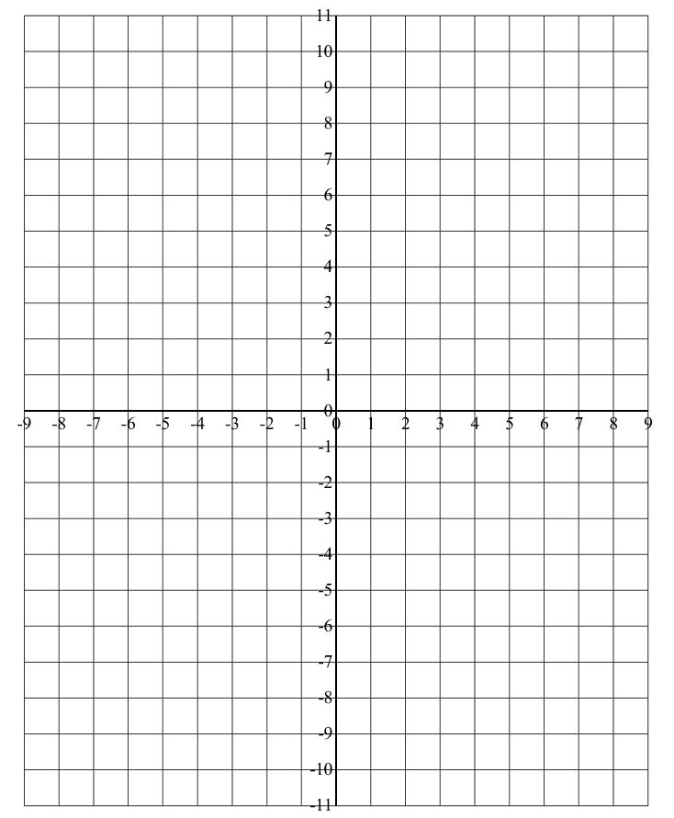
Group A - Write the equations of the lines in slope-intercept form. Then draw the graph of the lines on your own graph paper, labeling each line with its equation. Answer the questions that follow.

- slope = 1/2, y-intercept = 0 ___________________

- slope = 1, y-intercept = 0 ___________________

- slope = 3/2, y-intercept = 0 ___________________

- slope = 2, y-intercept = 0 ___________________

How are these lines alike? ___________________

How are these lines different? ___________________

What was the effect of changing the slope? ______________________________________
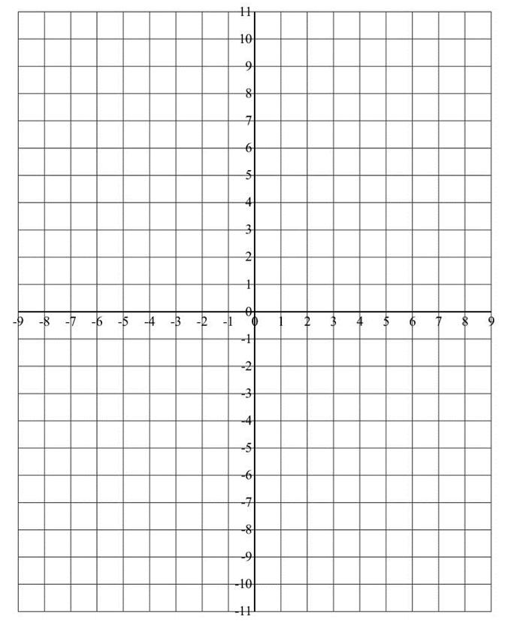
Group B - Write the equations of the lines in slope-intercept form. Then draw the graph of the lines on your own graph paper, labeling each line with its equation. Answer the questions that follow.

- slope = 2, y-intercept = 3 ___________________

- slope = -2, y-intercept = 3 ___________________

- slope = 1/2, y-intercept = 3 ___________________

- slope = -1/2, y-intercept = 3 ___________________

How are these lines alike? ___________________

How are these lines different? ___________________

What was the effect of changing the slope? __________________________________

