Functional Communication Assessment and Intervention Plan
Gretchen Morris-Archinal
SED 6050
7/22/2013

Functional Communication Assessment and Intervention Plan

Selection of a child

Andrew is an almost 10-year old who has just completed the third grade. Andrew has an educational diagnosis of ASD. He has a twin sister who has completed fourth grade and he lives at home with his mother, his twin and an older sister. Andrew is quite verbal is the ASD categorical room, but is very quiet in the general education setting. According to his gen ed teacher, Andrew said very little other than “Good Morning” for most of the year. He did start to speak more in the 3rd grade class room during the last two months of school.
Determine Function and Means of Communication
From highly verbal in one setting to a probable selective mutism in others settings, Andrew is fascinating because his use of speech, language and other communication skills varies so much by setting. Andrew was observed in three different settings: the ASD categorical room, his third grade gen ed classroom, and in the library presenting a Reader’s Theatre play in front of peers, parents and school staff.
The widest range of function and means of communication are present when Andrew is in the ASD room. He is in the room for about 2/3rds of his day. He spends the first ½ hour to 45 minutes in the gen ed room and then comes to the ASD room until lunch. He has lunch with his peers and then returns to the ASD room for DEAR (Drop Everything and Read) time until his gen ed specials. From 1:45 to 2:40 pm he is in the ASD room and then attends Science/Social Studies with his peers. During his time in the ASD room, Andrew requests objects and requests action by pointing, showing, head nods, facial expression and creating multi-word responses. While he rarely protests, Andrew does so with head shakes, facial expressions and multi-word responses. Most of Andrew’s social interactions utilize proximity, head shakes, facial expressions and creative multi-word expressions. When requesting permission and showing off, he will add showing to his means of communication. Andrew does not use proximity to comment or request information.
In the general education classroom, Andrew has been almost completely pre-verbal in his means of communication. He is beginning to add created multi-word responses to his repertoire. When requesting an object, Andrew will use facial expressions. He also uses facial expressions to protest. There is more use of communication means with Andrew’s social interactions. He will use gaze shift, head shakes, facial expressions and now multi-word expressions when requesting social routines and when he is greeting. He will use facial expressions to request comfort.
Performing as the dog in the reader’s theatre event was very hard for Andrew. Because of his anxiety, signs were created so that the audience could “hear” his lines. He did speak them aloud, but they were barely audible. He discomfort was evident, but so was his courage. In this setting, his request for comfort and greeting were conveyed by gaze shifts, proximity, head nods, and facial expressions. Andrew did use creative multi-word expressions to greet, show off and provide information. This was an area where Andrew’s selective mutism was apparent. He used it to not verbally respond to my questions regarding the following: social routine, comfort, greeting, calling, showing off, commenting, and providing information.
Determining Interventions
Andrew’s goals and objective should include the following:
- Objective 1: The student will follow an individual daily schedule.
- Objective 2: By June, 2014, Andrew will maintain a topic across three turn takings with visual and verbal prompts at 100% complience as evaluated through systematic observation.

To help facilitate the interventions across locations, people and time, Andrew will have the following either with him or on his desk in each classroom. A set of Stop and Go cards are available for him. These are laminated cards are similar to the illustration below. These cards can be used as a visual reminder of turn taking in conversations.
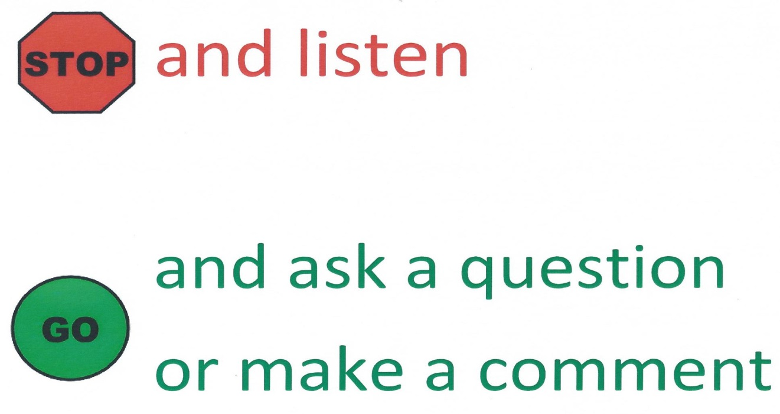
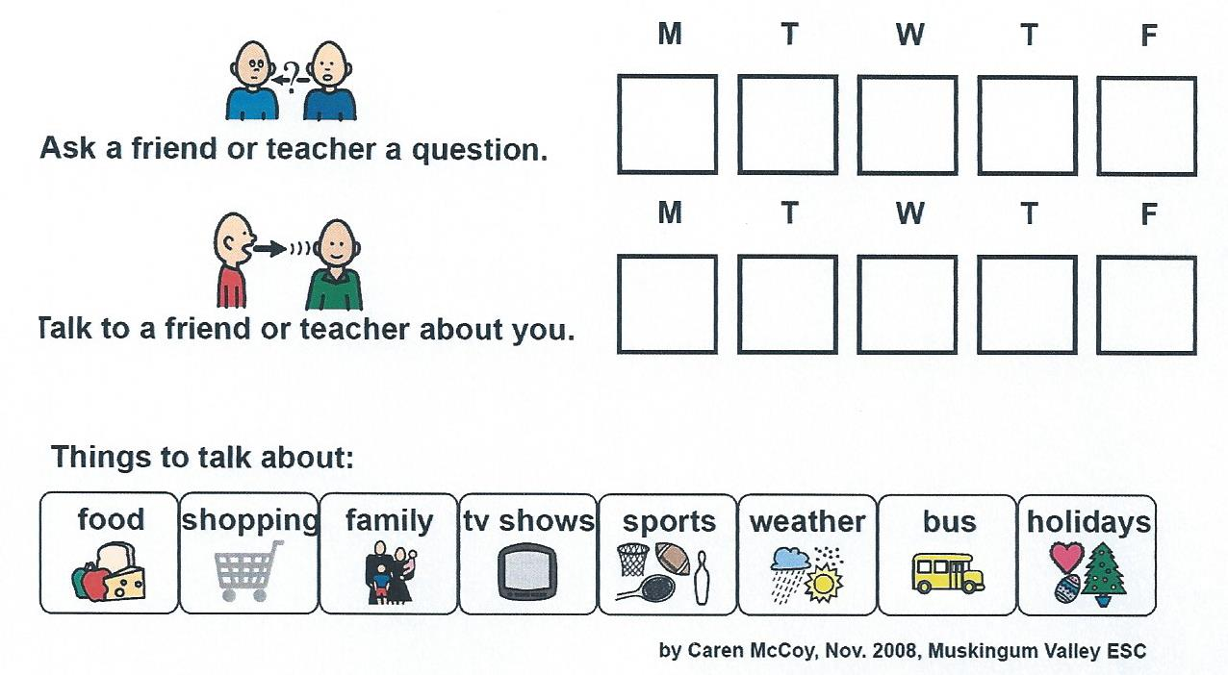
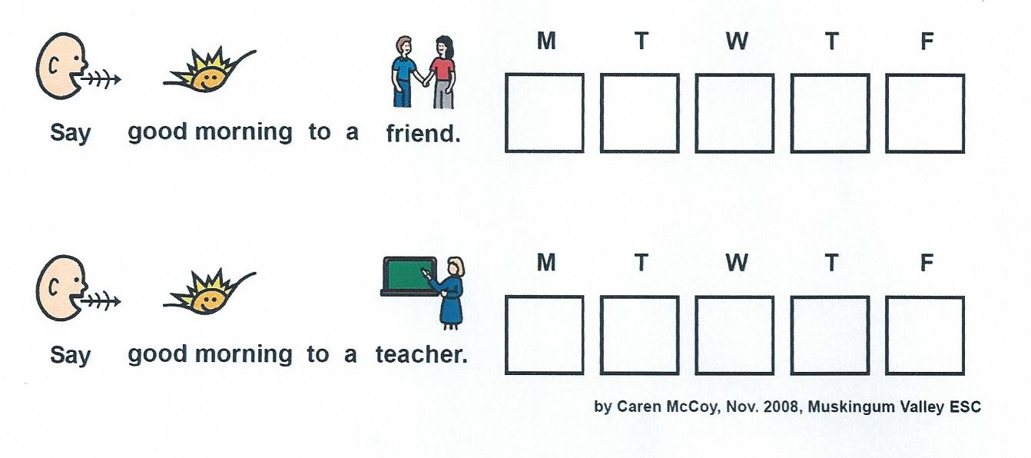
Another intervention is to use tally sheets as a reminder for Andrew to make conversations throughout the day. One form reminds him to say good morning to a friend as well as to say it to his teacher. The other form is a visual reminder to ask either a friend or a teacher a question or to talk about himself. Both of these forms use a combination of pictures and words. This combination is appropriate for Andrew given his present reading level.
Planning Activities across the Day
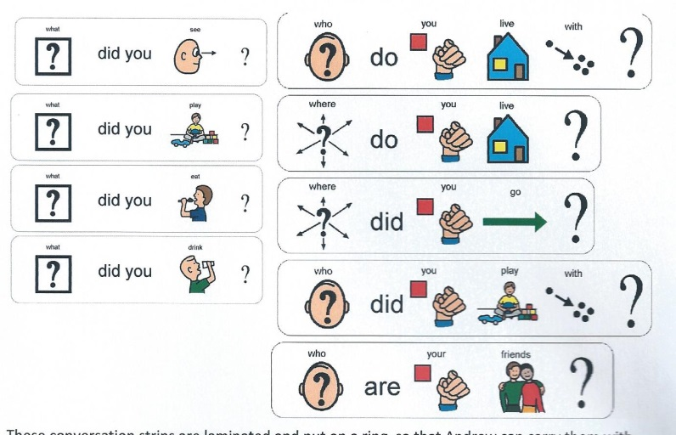
Four different activities have been developed to facilitate and learn about conversations during the course of Andrew’s day. The first activity for the day is during EEKK time. EEKK stands for Elbow, Elbow, Knee, Knee. Generally, two students sit elbow to elbow, knee to knee and read together. I have adapted this to work on conversational skills with Andrew. His partner can be either another student or an adult. This activity is schedule to run from 9:40 to 9:55 in the morning. The objective of this activity is to give Andrew practice at making conversation using topics that are not necessarily preferred. Conversations during this activity will start out with answering and discussing teacher directed questions from the group reading time held just prior to this activity. This activity works as a transition from group reading into practicing conversations. It also helps Andrew with content and recounting narrative sequences which are also problem areas for Andrew. Given Andrew’s present reading level, pictures and words will be combined to help assist with his functional reading. Once the questions for the group reading are done, the partners may choose one of the conversation starters on Andrew’s conversation ring. These again include both words and pictures and are similar to the examples above. These conversation strips are laminated and put on a ring, so that Andrew can carry them with him during the course of the day for conversational ideas.
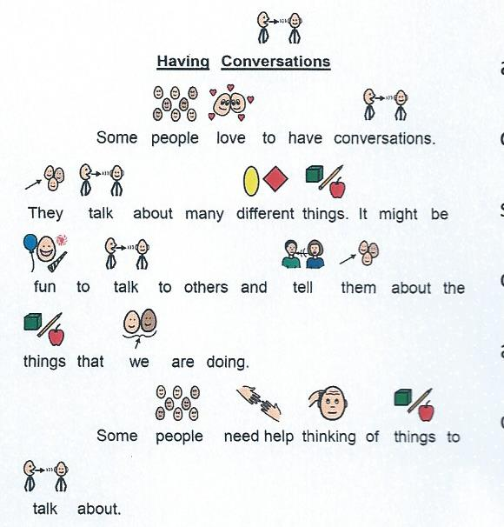
The second activity takes place from 10:25 to 10:40 am during Reading with Mrs. A. time. This is time for one-on-one reading instruction. “Having Conversations” is a social story using pictures and words to illustrate different conversational topics. This social story will be read by Andrew as part of his reading practice on a daily basis for the course of at least a week. The objective of this activity is to not only strengthen Andrew’s reading skills but to help him recognize the wide range of topics available to him when initiating a conversation with a person.
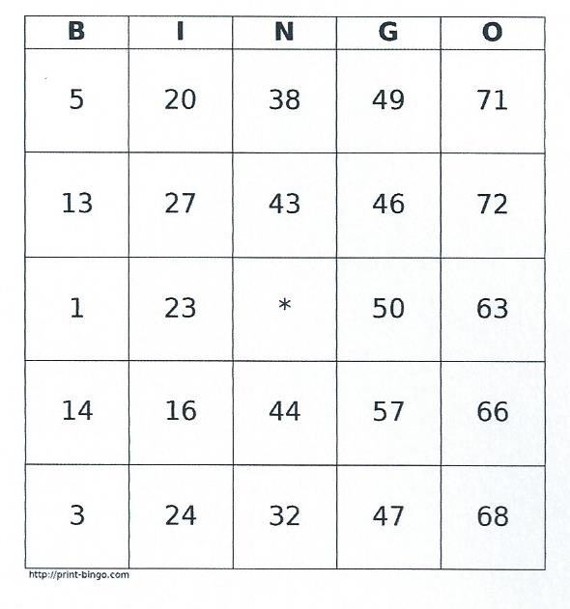
Smart Math time is a perfect time for working on conversations with peers. Generally, Andrew and Aydan, a fourth grade classmate work together from 10:40 to 11 am using the smart board and math related websites. They really enjoy different types of bingo. While this version is not done on the smart board, it will be a very familiar activity for both of them. This activity’s objective is to use turn taking and requesting of different items like the dice and bingo chips. This is also a perfect opportunity to work on conversations around needing help. For this game, each player will need a board with twenty -five numbers written on it, three dice, and tokens. The game starts by having the students roll all three dice at once. Each player then uses any operation to hit a target on his bingo board. Let’s say 2, 4, and 5 are rolled: player one wants to mark off 22 on her board so she uses (4x5)+2. Player two wants to mark 6 on his board. His equation is (2x5)-4. Player three marks 10 with (4x5)/2. The round continues until someone makes DINGO (five in a row). This game can be modified by changing the number of dice and featuring a smaller variety of math operations so that the game is educationally appropriate.
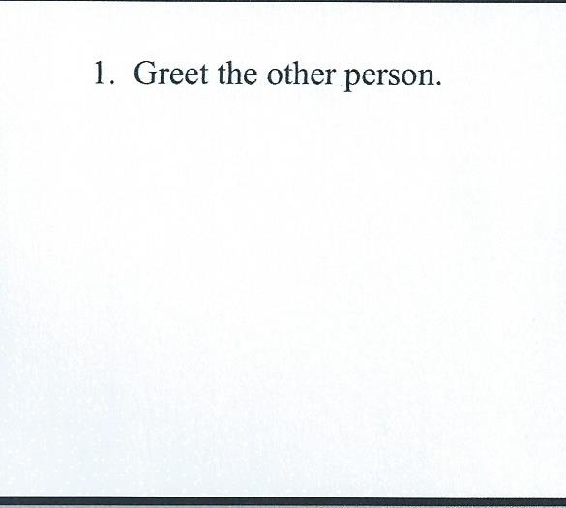
The fourth activity acts as both writing and drawing activity as well as an informal assessment of Andrew’s conversational skills. “Let’s Have a Conversation” is a six page activity that invites Andrew to write and illustrate his own social story about the art of conversation. Each page has a conversational step:
- Greet the other person
- Make eye contact
- Take turns talking and listening to the other person
- Ask questions when something isn’t understood or to keep the conversation going.
- Say “good-bye”, “see you later”, or “have a nice day”.
While the other activities have focused on conversational topics, this social story works on the more practical aspects of conversation. This is an opportunity for Andrew and an adult to talk and converse about how to do each portion of conversation from greeting to ending. The objective of this opportunity is to work on the nuts and bolts of conversation. This project would be done over the course of the week with Andrew working on a page a day. Writing is generally done from 11 to 11:20 am.
Family Input and Generalization of Skills
Because of Andrew’s comfort level, he appears to be much more verbal and conversational at home than at school. To accommodate this difference, a set of Stop and Go cards will be sent home with Andrew so that he can practice the reciprocal nature of conversation. Using visual signals of when to stop and let the next person talk and when to go and ask question or make a moment, Andrew is leaning the rhythm of conversation.
The other area that will be practiced at home is staying on topic. The following form will be sent home as home work. A communication partner records Andrew’s responses during a conversation. If the response is on topic, the sentence is recorded in the circle. If the response is off-topic, then it is recorded on the outside of the circle.
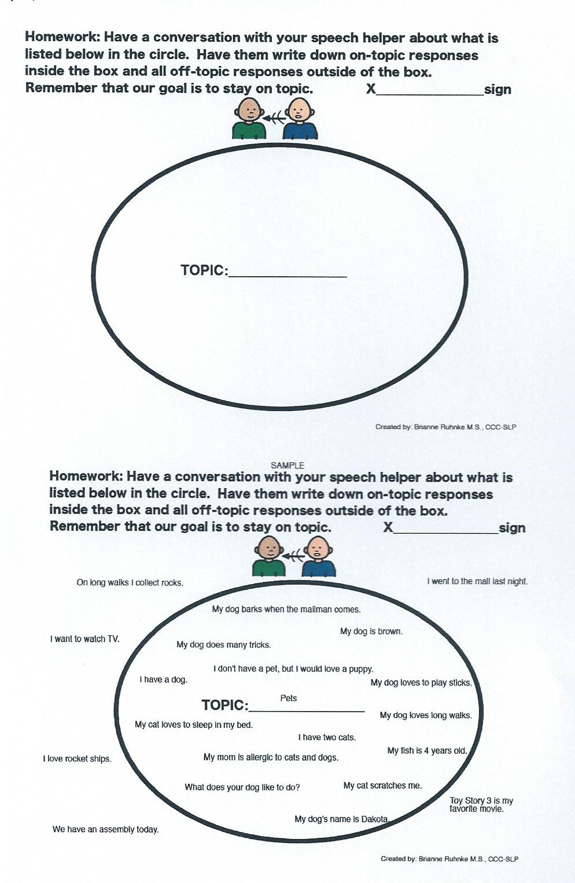

The goal of this activity is to practice staying on topic in an environment where Andrew is more likely to have an extended conversation. As Andrew gets more comfortable in school, this will be introduced in the ASD room and then finally in the general ed setting to generalize the learning of staying on topic.
Outcomes
I have high hope for the interventions and activities. The most of the activities dovetail into areas of strength for Andrew. He loves to draw so I can see the “Let’s Have a Conversation” book as being a favorite of his. Andrew also likes to play Bingo and enjoys working with Aydan so there will be more natural conversations during this activity. Reading “Having Conversations” may be a challenge for Andrew given is reading, but with the visual supports, I believe he can read and comprehend the material. I imagine that EEKK may be the hardest activity for Andrew. So much of the level of his conversation is dependent on Andrew’s level on anxiety. At least initially, this conversational partner should be some one that Andrew is very comfortable around and should be an adult that can draw him out of his shell. Each of the four activities also target different areas of conversation.
I am concerned about the home component as it does not appear that Andrew gets a lot of support at home. However, I think that using the Stop and Go cards, as well as, the recording of on-topic and off-topic will be helpful and useful for generalizing reciprocal speech from school to home and staying on topic from home to school.

