Classroom Organization and Management Plan Assignment

My philosophy of classroom management is an amalgamation of several of the leading researchers on classroom management. Richard Curwin and Allen Mendler’s Discipline with Dignity: A Classroom Behavioral Model strikes a chord with me because it is how I want my classroom centered around respecting both students and adults. I have seen how effective rewards can be for appropriate behavior. I think praising positive behavior is more effective in changing student behavior than punishing misbehavior. What is often seen as misbehavior in students is often their way of communicating with us using very awkward social communication skills and not the “misbehavior” that we interpret it to be. All students need to be reminded and praised for making good decisions and this is a skill that they will utilize the rest of their lives.
From a classroom management perspective, there are far less behavioral problems when students are interested and engaged in learning. Cognitivism, by its definition is to make work and learning meaningful and thus students are too busy in the process of learning to be disruptive and behavior problems in the classroom. Fred Jones’s Positive Classroom Discipline Model stresses that the correct ways to implement and use an incentive system in the classroom called Preferred Activity Time (PAT). By providing meaningful work, the students are engaged and responsible for earning their reward. PAT incorporates both behavioral and cognitivism in classroom management. Jones also suggests that the teacher should be “positive, be brief and be gone” by providing quick and effective help in the classroom when the students have problems even with meaningful work. Harry Wong offers some very practical suggestions in his To-Do List for teachers whether they are just starting out or veterans.
Creating a community of learners is very important. My vision is that this community encompasses learners of all ages and abilities. This community should be a safe place were all feel welcomed and a part of a larger family. To do this requires the following:
- All students are active participants in the classroom
- Students need to contribute to and build on one another’s efforts to build their knowledge.
- Discussion and collaboration between students is needed and necessary.
- Diversity in students interests and rates of learning is expected and respected
- No one has the exclusive responsibility of teaching. This is shared between the students and the teacher.
- All learners are potential resources for others.
- The teacher as well as other students offer guidance and direction for classroom activities
- Students regularly share and critique each other’s work. This can be done utilizing the computer.
- The process is as important and sometimes more so than the product.
Peer relationships are important for creating a sense of community in the classroom. This community “values the contributions of all students, using everyone’s individual backgrounds, cultural perspectives and unique abilities to enhance the overall performance of the class.”(Ormrod, pg. 90-91)
As a teacher, one the biggest components of my job is to modify and adapt learning instruction to the individual. It is important that all students are able to engage in learning in a way that is meaningful and effective for them. I am always on the lookout to find better ways to teach a topic and reach a student.
There are just four classroom rules in my classroom:
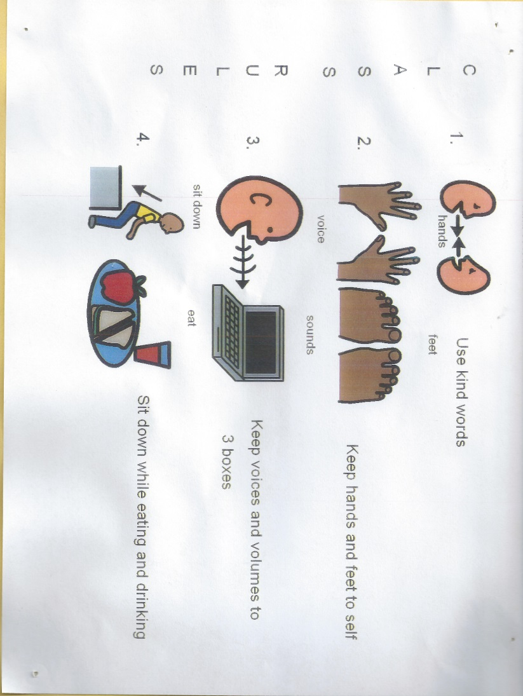
Positive Reinforcements include the following: praise, smile, high five, preferred activity, spending a couple more minutes at recess, stickers, or a hug. Inappropriate behavior is handled in the following manner:
1. Non-verbal Warning – Positive Redirection
2. Verbal Warning – Positive Redirection
3. Verbal Warning – Move clip or card
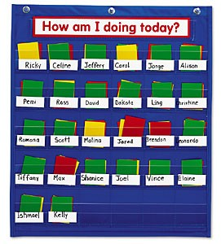
The school has a behavior chart system in place which I use with a twist. I am a firm believer in grace and redemption. I offer student a chance to move from a flipped card to green. For some students, once they have to flip their card to a different color the day is lost. By allowing students a chance to move back to green, the students have an incentive to improve their behavior and make better choices. I focus on positive behavior rather than negative behavior.
A PBS Program entitled Get Caught Making Good Choices is also in place. There is a PBS party/special event at the end of each month as the reward for being caught making good choices
Month One – Classroom Rules
Month Two – Hallway Rules
Month Three – Bathroom Rules
Month Four – Office Rules
Month Five – Recess Rules
Month Six – Cafeteria Rules
Month Seven – Arrival/Departure Rules

Transitions in a classroom can be an issue. Generally speaking, I will use timers to give the students a visual idea of the time they have left for a task. Depending on the student, 5 minute and 2 minute warnings will be used. Students may go to the bathroom upon request. One boy and one girl at a time may leave the room for the bathroom. Students will stop for a bathroom and water break on the way back from specials. Pencils should be sharpened at the beginning of the day. I have a supply of extra sharpened pencils. Home communication folders are brought in and put in the in-box. The home communication folders are returned to the students at the end of the day. Lunches are kept in the students’ lockers.
My classroom is a reflection of my philosophy. There are different areas that allow for different types and styles of learning. Each student has an individual work space that is grouped for small group activities. There is a whole group learning area that includes a rug and access to the smart board. The quiet reading area is for the necessary down times. The room has two computers and two iPads that are used for learning. The computers on the teacher’s desk are for the primary use of the teacher. The walls have the PBS charts, learning aids/posters and student art work.

Student Desk

Teacher Desk

Group Table

Book Shelves

Teacher Curriculum Resources

Computer

Sofa

Windows

Smart board

Doors

Small book case

Student lockers are located in the hallway outside of the classroom.

Floor Lamp

Rug

Group Lesson Area
Quiet Area
Student Work/Personal Spaces
Teacher Area
Technology Area

